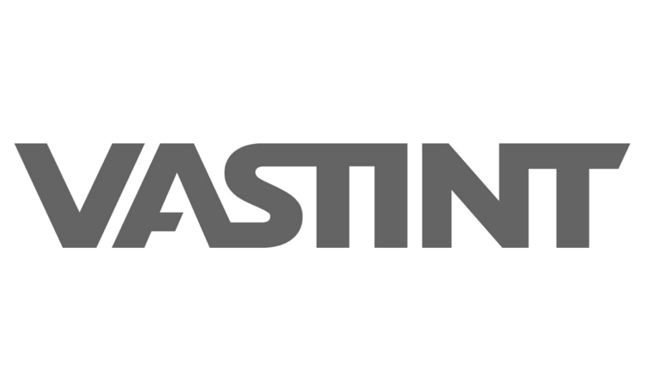
PRIVACY CHAMPIONS GUIDE

Responsibilities |  | Pro-active
• Act as first contact on privacy topics and involve the DPO when needed.  • Support compliance: keep the ROPA, notices, agreements, and other privacy documents current; ensure procedures such as DPIAs, IT monitoring, and CCTV are followed.  • Applicants and new colleagues: send the privacy notice, collect only needed data, and delete rejected CVs unless retention applies.  • New vendor or website: use the right Data Processing Agreement template and update the notice, cookie statement, banner, and ROPA. |  | • New system: check DPIA need, review security, inform the DPO, and update the ROPA.  • Marketing emails: prior consent plus an unsubscribe link.  • CCTV: follow the policy and notice, ensure signage, and assess DPIA need for each location.  • Review ROPA, websites, privacy statements, cookies, and the consent banner.  • Check vendor agreements.

Re-active |  | Daily habits
• Data Breaches: Treat a wrong recipient, lost device, hacking, or unavailable data as a possible breach.  • Assess whether it is a personal data breach under GDPR and involve the local law firm when needed. Notify IT at IT@vastint.eu and email the privacy@vastint.eu. |  | • Clean Desk Policy: Keep desks and screens clear. Lock screens when you step away.  • Share personal data only with people who need it, using approved tools.

Templates and guidance |  | Annual review
• Where to find the templates?  Teams > Privacy Champions Team > General  • Complete guidance: Use the Interogo Personal Data Protection Manual & Templates.  • No suitable template? Ask lucas.noronha@vastint.eu |  | • You can find the Annual Checklist Review in your Teams channel:  Vastint [your country] → Assessments & Reports Privacy → Champion Annual Review Checklist

The central privacy team  Johan Martens - Group Data Protection Officer (DPO)  Johan.Martens@vastint.eu  Lucas Noronha - Privacy Officer  lucas.noronha@vastint.eu  Anna Hägg - General Counsel  anna.haegg@vastint.eu  Paul Wiltjer - Chief Information Officer (CIO)  paul.wiltjer@vastint.eu  Ryan Yallop - IT Manager  ryan.yallop@vastint.eu |  | Questions?  Check our GDPR Training  Contact lucas.noronha@vastint.eu

